

Software Engineering Department

Braude College

Capstone Project Phase A

**DreamForge: Idea Builder & Project Generator**

**24-1-D-34**

Supervisor: Alex Keselman  
 [Alex@vir-tec.net](mailto:Alex@vir-tec.net)   
Or Yosef – 208778670  
[oryosef197@gmail.com](mailto:oryosef197@gmail.com)

Yaniv Lippa – 303032122  
[Yaniv.lippa@gmail.com](mailto:Yaniv.lippa@gmail.com)

**Our GitHub:**

<https://github.com/OrYanivProject/Final-Project>

**Table of Contents**

1. **Introduction3**
2. **Background and Related Work4**
3. **Expected Achievements5**
4. **Engineering Process6**
5. **Product7**
   1. **Requirements**7
      1. Functional Requirements7
      2. Non-Functional Requirements8
   2. **Work Stages**8
   3. **Diagrams**9
      1. Use Case Diagram9
      2. Class Diagram10
      3. Sequence Diagram11
      4. Activity Diagram12
   4. **User Interface Prototypes**13
6. **Testing Plan16**
   1. **Unit Testing**16
   2. **Functional Testing**17
7. **References18**

**Abstract**

In the rapidly evolving landscape of technology, there is a continuous need for innovative platforms that simplify and enhance project development processes. This project introduces a revolutionary platform designed to transform the way ideas are developed into structured projects. Utilizing the capabilities of the advanced ChatGPT-4 API, this platform allows users of any knowledge level to input their project ideas and receive a meticulously crafted project book. This book includes comprehensive documentation generated by AI, offering users a seamless transition from conceptualization to detailed project planning, regardless of their prior experience.

The core of this platform is its ability to analyze and understand user inputs through sophisticated natural language processing techniques. By interpreting the essence of the submitted ideas, it dynamically generates documents such as project scopes, objectives, required materials and potential challenges tailored to each project's unique requirements. This adaptability makes it particularly valuable, as it caters to both novices and seasoned professionals alike, enabling them to focus more on the practical aspects of execution rather than the nuances of preparation.

As technology continues to permeate all sectors, this platform stands out by bridging the gap between abstract ideas and concrete plans, fostering innovation and efficiency in project development. It represents a significant leap towards the future of automated project documentation and management, promising to be an invaluable tool for a wide array of users seeking to bring their visionary projects to life with precision and ease.

**1. Introduction**

In today's digital age, the generation and documentation of project ideas remain an essential yet often challenging process. Individuals and organizations frequently face difficulties in transforming innovative concepts into structured, actionable projects. The crux of the problem lies in the lack of resources that can seamlessly convert raw ideas into comprehensive, organized plans, particularly for those with limited technical or project management experience.

Presently, several solutions attempt to address this issue, including various project management tools and platforms that provide templates and guidance for project development. However, these tools often require a certain level of expertise or familiarity with project management principles, which can be a barrier for beginners. Furthermore, they do not offer personalized, detailed, and context-specific project documentation automatically generated from an initial idea input, leaving a gap in accessibility and customization.

Our proposed solution is a platform that leverages the advanced natural language understanding capabilities of the ChatGPT-4 API to create a user-friendly interface where individuals can input their project ideas, regardless of their expertise level. The platform will then generate a comprehensive project book that includes all necessary documentation such as objectives, scopes and required resources. This automated process will not only streamline project documentation but also enhance the accuracy and creativity of the resulting plans.

The primary stakeholders encompass individuals with varying levels of expertise, ranging from those well-versed in development strategies and goal setting to those with limited prior knowledge. This inclusive approach ensures that both seasoned professionals and novices can effectively leverage the system's dynamic architecture and harness the power of existing artificial intelligence technologies.

**2. Background and Related Work**

The advent of artificial intelligence (AI) has led to significant advancements in project management tools and documentation generators. While existing AI-driven systems offer various benefits, they also come with certain limitations. This section examines the current landscape of AI-driven project management tools and documentation generators, highlighting both their strengths and weaknesses.

Project management tools like Project Insight, Wrike, and Notion integrate AI to enhance functionalities such as task automation, resource allocation, and project tracking. However, these platforms may have limitations in terms of customization and adaptability to unique project requirements. While they offer efficiency gains through automation, they may lack the flexibility to accommodate complex project structures or unconventional workflows. Additionally, the reliance on AI algorithms for decision-making may sometimes result in suboptimal outcomes or inaccuracies, especially in dynamic project environments where human judgment is crucial for nuanced decision-making.

Similarly, in the domain of documentation generation, tools like Scribe and IntelliJ IDEA leverage AI to streamline the creation and maintenance of project documentation. While these tools automate the documentation process and ensure accuracy, they may have limitations in terms of comprehensiveness and customization. AI-generated documentation may lack the human touch and context provided by manual documentation efforts, leading to potential gaps or inaccuracies in the documentation. Additionally, the reliance on AI algorithms may introduce biases or errors in the generated content, which could impact the credibility and reliability of the documentation.

Despite these limitations, the integration of AI in project management and documentation tools represents a significant step towards efficiency and productivity. However, there is still room for improvement in terms of addressing the limitations and enhancing the capabilities of AI-driven systems. Our project, as a project book generator, aims to address these limitations by providing a customizable and adaptable solution for project documentation. By leveraging AI for efficient documentation generation while also allowing for human input and customization, our project seeks to offer a more comprehensive and reliable solution compared to existing tools in the market.

**3. Expected Achievements**

The primary goal of this project is to develop a comprehensive, AI-powered platform that facilitates the creation of structured project books from initial ideas submitted by users. This platform will be developed using a combination of modern technologies including Preact for the frontend, Node.js for the backend, and MongoDB for the database, leveraging the ChatGPT-4 API for generating content.

**Success Criteria:**

Functionality: The platform must accurately interpret user inputs and generate complete project documentation.

Usability: Users should find the platform easy to navigate and use, regardless of their technical skill level.

Performance: The platform should handle a high volume of user requests without significant delays.

Security: User data should be securely stored and handled with no breaches or vulnerabilities.

**4. Engineering Process**Our primary focus thus far has revolved around researching available technologies in the market to carefully select the most efficient approach for project completion. We've set up the required work environments for the upcoming steps and focused on mastering the diverse technologies required for the development phase. Looking ahead, our aim is to establish an internet site using the chosen technologies, leveraging the artificial intelligence abilities given by the ChatGPT’s API.

We chose Preact for the frontend because it's lightweight and compact. Its quick performance and small size make it an excellent choice for projects that need to meet strict performance and size requirements.

For the backend, we've chosen Node.js because of its exceptional ability to handle server configurations and API applications efficiently.

We chose MongoDB as our data storage solution for its efficiency and alignment with our project's needs, reducing overhead and unnecessary complexity.

The integration of the ChatGPT 4 API is a key element of our project, reflecting our goal to fully utilize advanced text manipulation capabilities. Our primary goal is to explore how effectively we can manipulate text to achieve the desired outcomes.

**Constraints**:

Our project relies heavily on ChatGPT-4, so we must follow OpenAI's terms of use. Unlike the standard use of the ChatGPT subscription, which offers a fixed monthly rate, using the API costs money per token used, for both the text we send and the replies we receive. Due to the large output which we expect by receiving a full project book, this pricing model requires us to be very careful with how we manipulate text to keep costs as low as possible and ensure we're building an effective product efficiently.

**5. Product:**

**5.1.1 Functional Requirements:**

|  |  |
| --- | --- |
| 1 | User Input Handling: The system shall allow users to input project ideas through a web interface. |
| 2 | Documentation Generation: The system shall generate comprehensive project documentation using the ChatGPT-4 API based on user inputs. |
| 3 | Database Interaction: The system shall store user inputs and generated documents in a MongoDB database. |
| 4 | User Authentication: The system shall support user authentication to manage access to personal and sensitive project data. |
| 5 | API Integration: The system shall integrate with the ChatGPT-4 API to process and generate project documentation. |
| 6 | Responsive Interface: The system shall provide a responsive web interface that adapts to different screen sizes and devices. |
| 7 | Data Retrieval: The system shall allow users to retrieve and view their previously inputted project ideas and generated documents. |
| 8 | Secure Data Handling: The system shall ensure secure submission and retrieval of data through the web interface. |
| 9 | Feedback Mechanism: The system shall include a feature for users to submit feedback on the generated documentation and system usability. |
| 10 | Continuous Updates: The system shall allow for continuous updates and improvements based on user feedback and system performance monitoring. |

**5.1.2 Non-Functional Requirements:**

|  |  |
| --- | --- |
| 1 | Usability: The web interface shall be user-friendly and easy to navigate for users with varying levels of technical expertise. |
| 2 | Performance: The system shall handle requests and generate documents promptly without significant delays. |
| 3 | Scalability: The system shall be designed to scale up efficiently as the number of users grows. |
| 4 | Security: The system shall implement robust security measures to protect user data from unauthorized access and breaches. |
| 5 | Accessibility: The system shall comply with accessibility standards to accommodate users with disabilities. |
| 6 | Reliability: The system shall operate reliably with minimal downtime. |
| 7 | Maintainability: The codebase shall be well-documented and structured to facilitate easy maintenance and updates. |
| 8 | Cost Efficiency: The system shall optimize API usage to minimize operational costs without compromising functionality. |
| 9 | Compatibility: The system shall be compatible across multiple browsers and devices to ensure broad accessibility. |
| 10 | Data Privacy: The system shall adhere to privacy laws and regulations to protect user information. |

**5.2 Work stages:**  
We will divide our work into stages so that we can perform it optimally.

1. Building a schema for saving the data in MongoDB, and then linking the database to the JS NodeJS.
2. Creating a backend using NodeJS, Design and implement API endpoints for user authentication, project submission, and retrieval.
3. Integrate ChatGPT-4 API: Set up calls to the ChatGPT-4 API to generate project files based on user inputs.
4. Creating the website using Preact, Design and implement the user interface for submitting project ideas and viewing generated project files.
5. Connect Frontend to Backend: Make API calls from your Preact frontend to send and retrieve data from the Node.js backend.
6. Deploy our application:
7. Choose a Hosting Solution: Decide where we want to deploy our application.
8. Configure Deployment: Set up deployment configurations and deploy

our Preact app and Node.js backend.

**5.3.1 Use Case Diagram:**

The Use Case diagram provides a high-level overview of the system's functionality, helping to define the scope of the project and understand user requirements. It highlights the key features and scenarios in which the system will be used, guiding the design and development process.

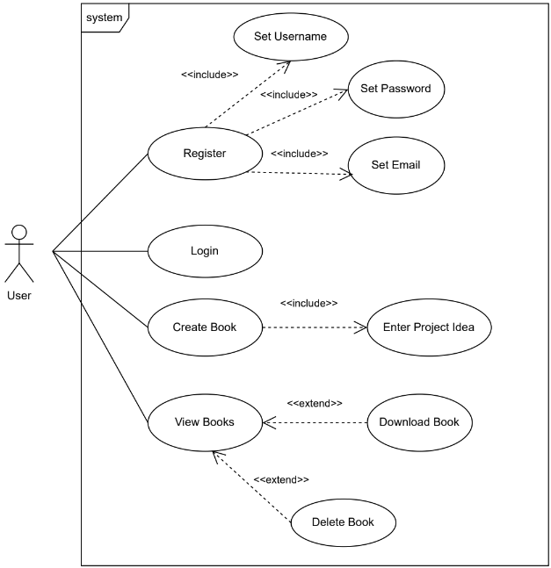

**5.3.2 Class Diagram:**

This is the class diagram for the project. While it may appear simple, its significance lies in its integration with the ChatGPT4 API and efficient manipulation of text.

**5.3.3 Sequence Diagram:**

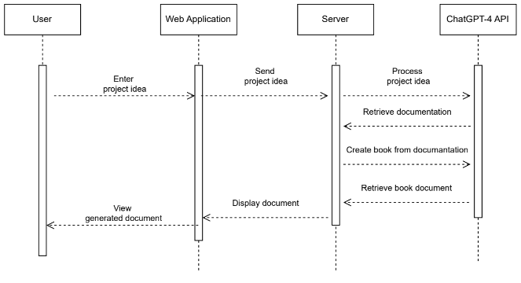This sequence diagram provides a visual representation of the flow of actions, starting from the user's interface with the web application, passing through the server, and reaching the ChatGPT4 API system.

**5.3.4 Activity diagram:**

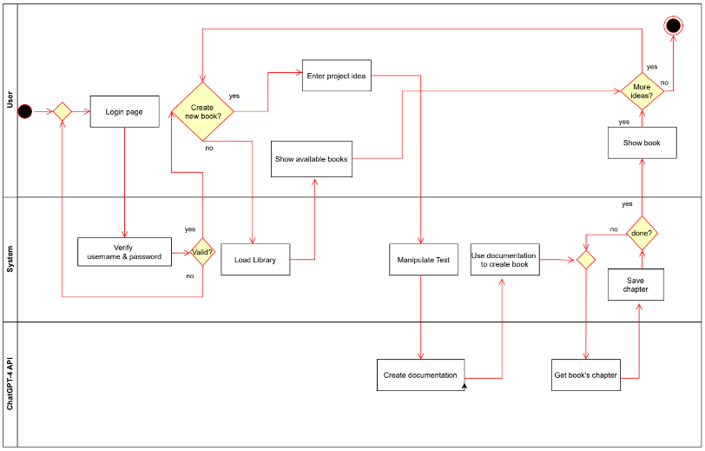This is the activity diagram, illustrating the sequential actions and interactions within the project's workflow.

**5.4 User Interface Prototypes:** 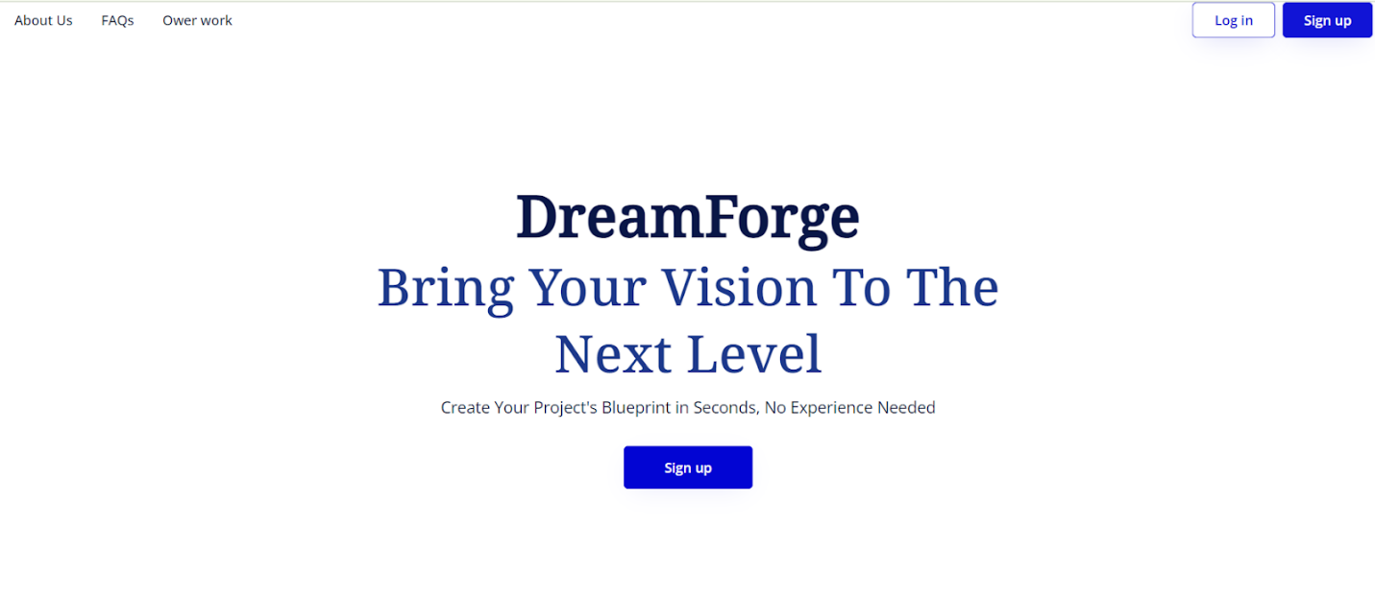 Figure 5: main webpage

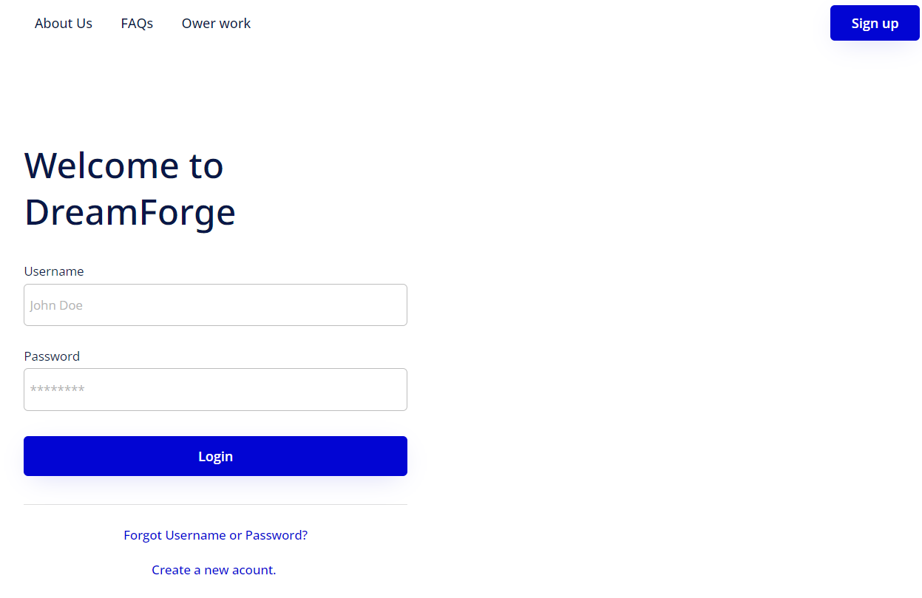

Figure 6: user login webpage

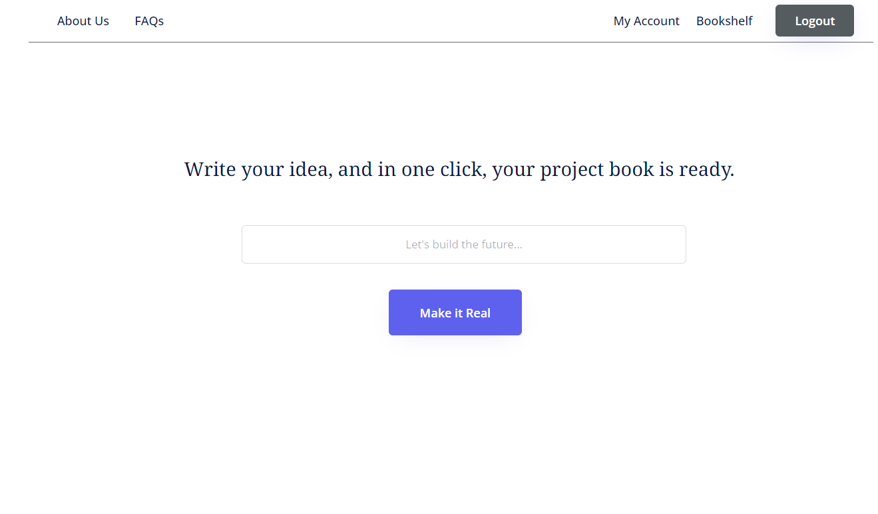 Figure 7: idea submission and book creation webpage

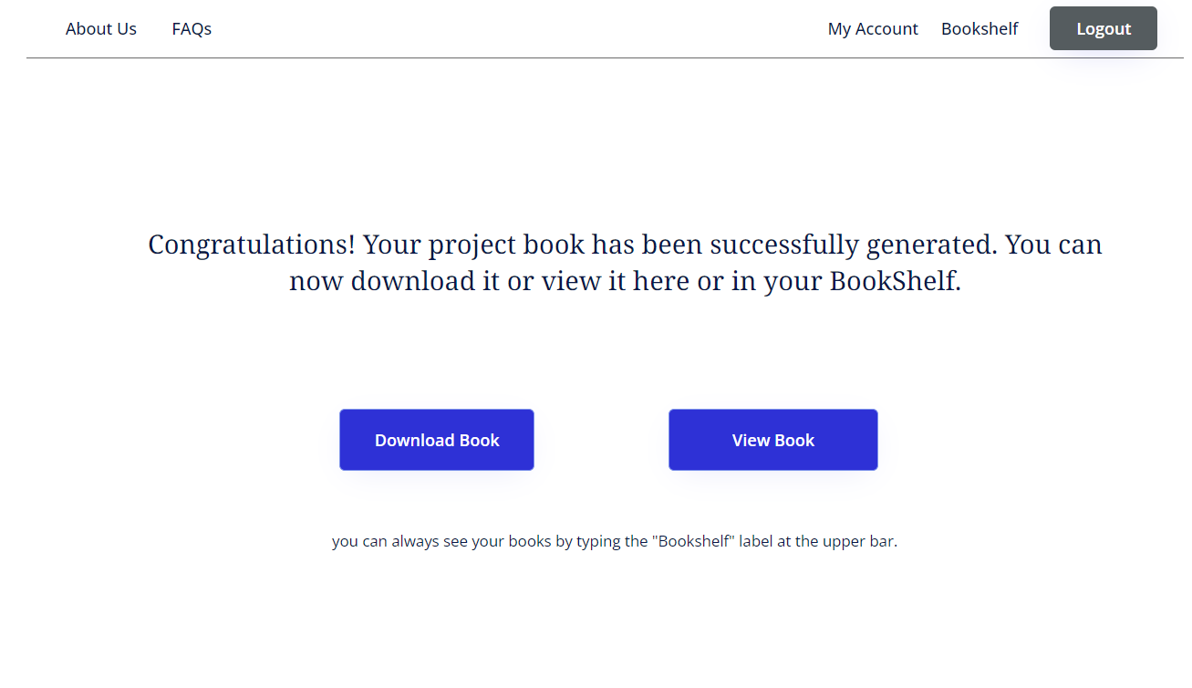

Figure 8: result webpage

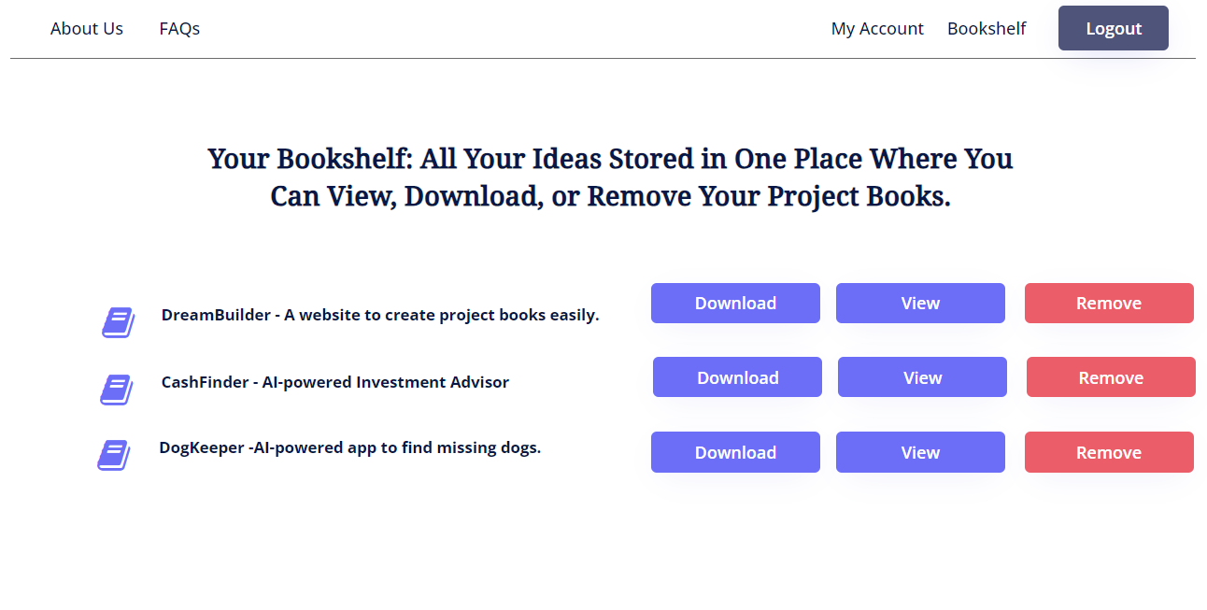 Figure 9: personal bookshelf webpage

**6. Testing Plan:** Our testing plan will be divided into two parts, unit testing and functional testing.

**6.1 Unit Testing:**

|  |  |  |  |
| --- | --- | --- | --- |
|  | **Interface Page** | **Test Subject** | **Expected Result** |
| **1** | Login | Enter valid user details and press “Login” button | The screen will switch to the “Idea submission” page |
| **2** | Idea submission | Enter a valid idea and press the “Make It Real” button | The screen will switch to the “Book created” page |
| **3** | Book created | press the “Download Book” button | The project book will be downloaded to the user’s computer |
| **4** | Book created | press the “View Book” button | The created book will be shown on the screen |
| **5** | Bookshelf | press “Remove” button for specific book | A warning message window will appear:  “Are you sure you want to remove the book?” |
| **6** | Bookshelf (warning) | press “Yes” button after warning appear | The book will be removed from the bookshelf |
| **7** | Bookshelf (warning) | press “No” button after warning appear | The screen will return to the original bookshelf screen |
| **8** | Bookshelf | press the “View” button for a specific book | The chosen book will be shown on the screen |
| **9** | Bookshelf | press the “Download” button for a specific book | The chosen book will be downloaded to the user’s computer |

**6.1 Functional Testing:**

|  |  |  |  |
| --- | --- | --- | --- |
|  | **Interface Page** | **Test Subject** | **Expected Result** |
| 1 | Registration | Enter invalid email | Message: “Invalided email address” |
| 2 | Registration | Invalid character entered | Message: “Invalid character used” |
| 3 | Registration | Enter already existing username | Message: “This username already exists” |
| 4 | Login | Enter wrong username/password | Message: “Wrong username or password” |
| 5 | Login | Enter an already logged-in user detail | Message: “This user is currently logged-in” |
| 6 | Login | Login with empty username or password | Message: “Must enter username and password” |
| 7 | Idea submission | Enter idea with less than four words | Message: “Idea must be more then four words” |
| 8 | Idea submission | Meaningless idea entered | Message: “Could not understand your idea” |
| 9 | Idea submission | Offensive text entered | Message: “Warning – your idea may be offensive” |

**7. References:**

1. <https://openai.com/index/gpt-4-research/>
2. <https://www.jetbrains.com/help/idea/generate-documentation.html>
3. <https://ieeexplore.ieee.org/stamp/stamp.jsp?tp=&arnumber=9402739>
4. <https://elearningindustry.com/role-of-ai-in-the-future-of-project-management>
5. <https://ieeexplore.ieee.org/stamp/stamp.jsp?tp=&arnumber=10355961>
6. <https://link.springer.com/article/10.1007/s11301-024-00418-z>
7. <https://www.projecttimes.com/articles/embracing-ai-driven-project-management-a-guide-for-pms/>
8. <https://www.researchgate.net/publication/363241110_Artificial_Intelligence_in_Project_Management_Systematic_Literature_Review>